JEE Lab Guide for ELITE

Contents
 | Introduction to labs | 2
 | Lab 1:  Installing Weblogic Server | 4
 | Lab 2:  Configuring domain | 9
 | Lab 3:  Basic Deployment | 13
 | Lab 4:  Configuring Data Source | 14

Introduction to Labs

Oracle WebLogic Server is a scalable, enterprise-ready Java Platform, Enterprise Edition (Java EE) application server. The WebLogic Server complete implementation of The Sun Micro systems Java EE 5.0 specification provides a standard set of APIs for creating distributed Java applications that can access a wide variety of services, such as databases, messaging services, and connections to external enterprise systems. End-user clients access these applications using Web browser clients or Java clients.

In addition to the Java EE implementation, WebLogic Server enables enterprises to deploy mission-critical applications in a robust, secure, highly available, and scalable environment.

Lab1: Installing Weblogic Server

Objective: Installing Bea Weblogic Server 10gR3 in GUI mode

Steps
- Click on oepe-wls-indigo-installer-11.1.1.8.0.201110211138-10.3.6-win32 application
Run the Installation program

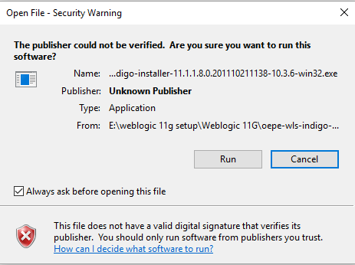

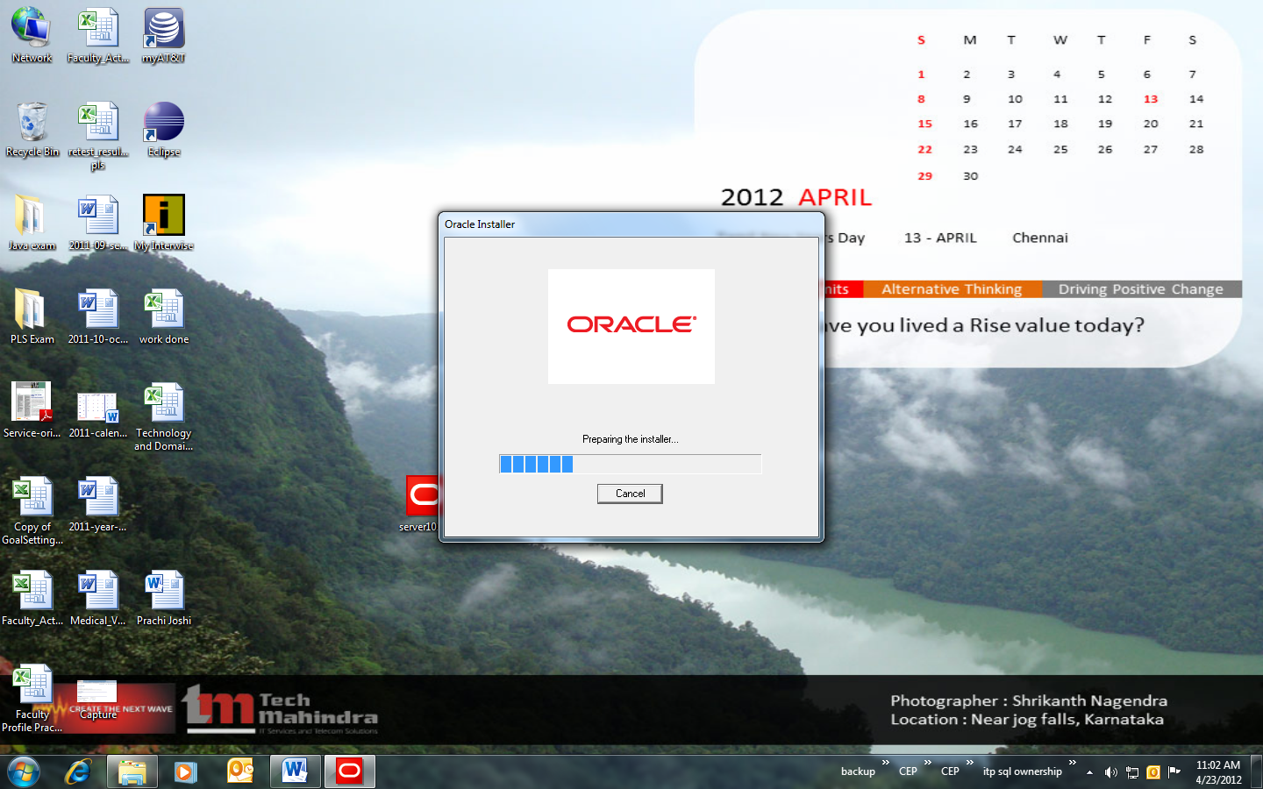

- On the welcome screen click Next to proceed with the installation

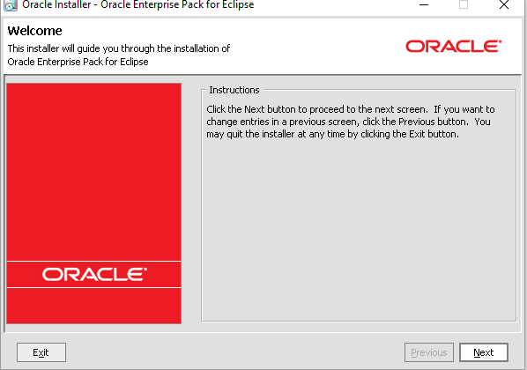

- Specify the oracle Home directory that will serve as the central support directory for all oracle products installed on the target system. If you already have a oracle Home directory on your system, you can select that directory (recommended) or create a new BEA Home directory. If you choose to create a new directory, the installation program automatically creates one for you. Specify C:\Oracle\Middleware as the home directory. Click on Next.

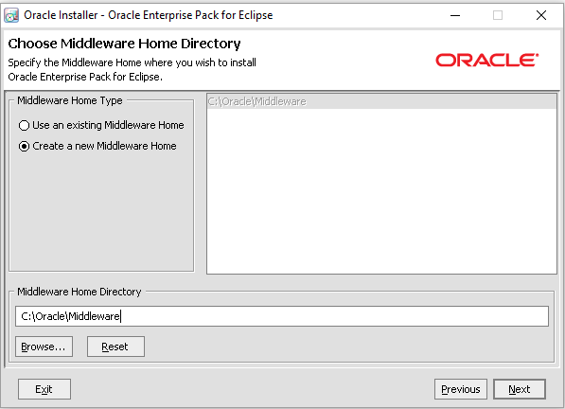

- Dis select below check box

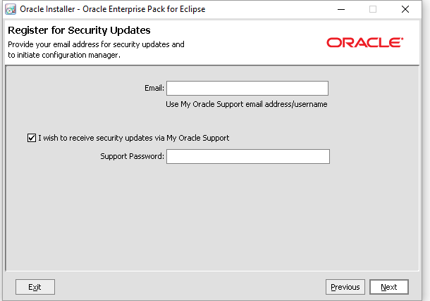

- Click on Next.

- Click on Next.

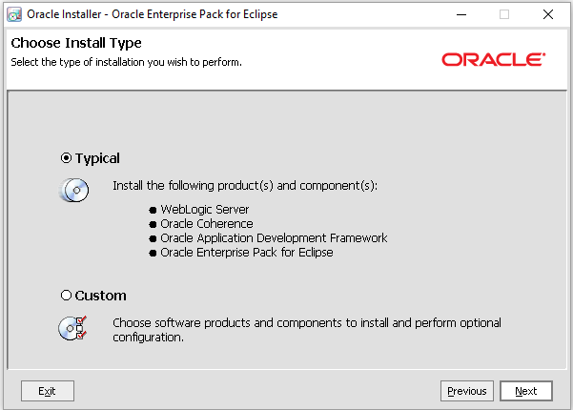

- Click on Next.

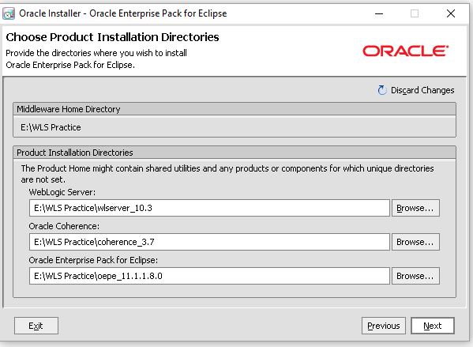

- Click on Next.

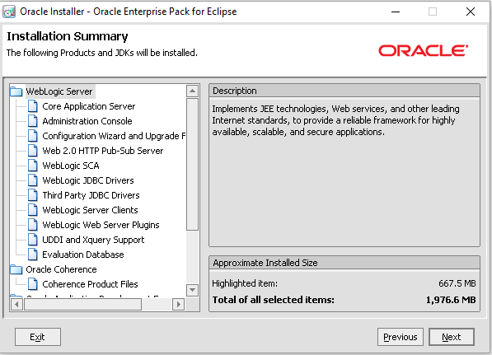

- This will start the installation :

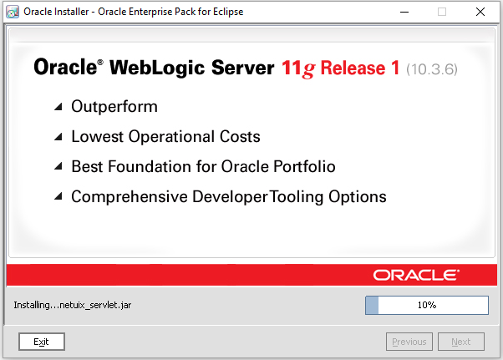

- Specify whether you want to run the QuickStart application. Click Done to exit the installation program and launch QuickStart, if selected.

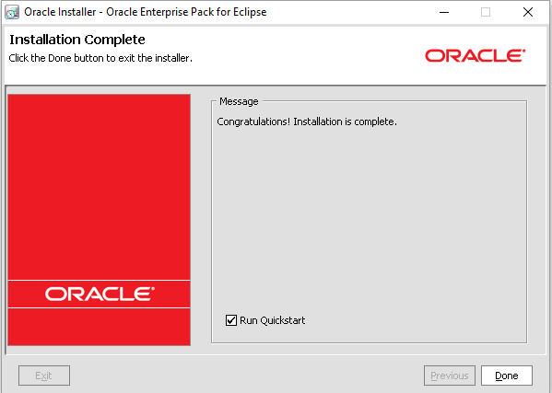

Lab2: Configuring domain

Objective: Creating and configuring domain to include Admin server and managed servers

Steps to configure domain
- Start the configuration wizard (All Programs → Oracle Weblogic → Weblogic Server 10gR3 → Tools → Configuration Wizard)
- To create a new domain, choose Create a new WebLogic configuration

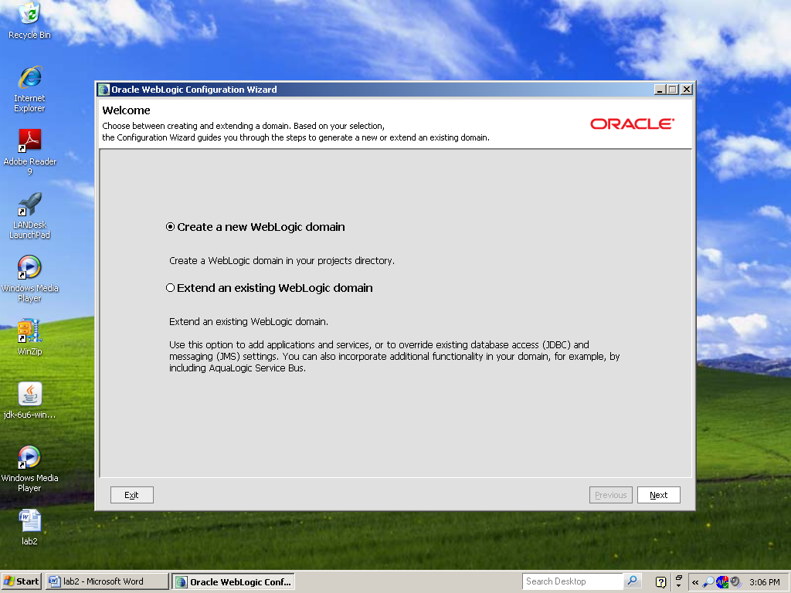

- Choose the configuration template with which you want to create and configure your domain. Here keep the default.
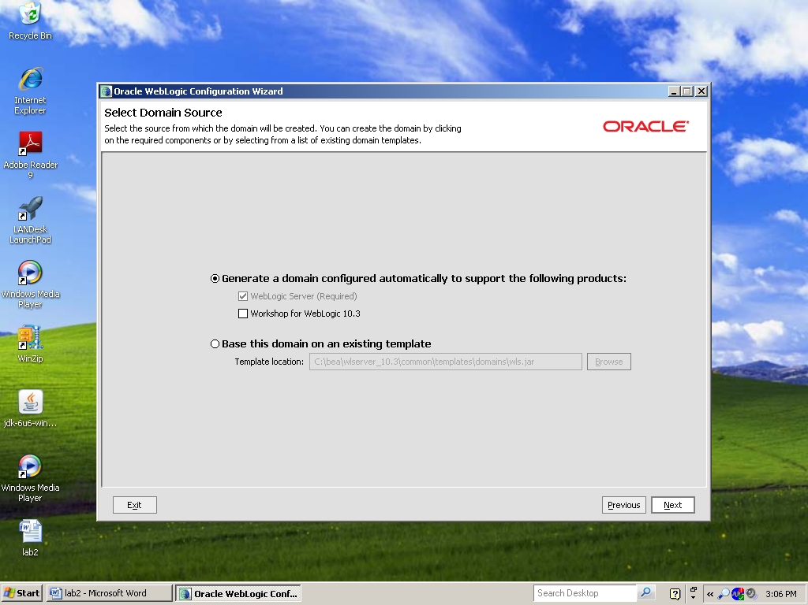

- Specify an administrative username and password. Specify following
  - Username: weblogic
  - Password: weblogic
- Select the mode in which to launch your WebLogic domain configuration (development mode or production mode). Select development mode.
- Select the Java Software Development Kit (SDK) that is enabled for the selected Startup mode. Select Sun SDK.

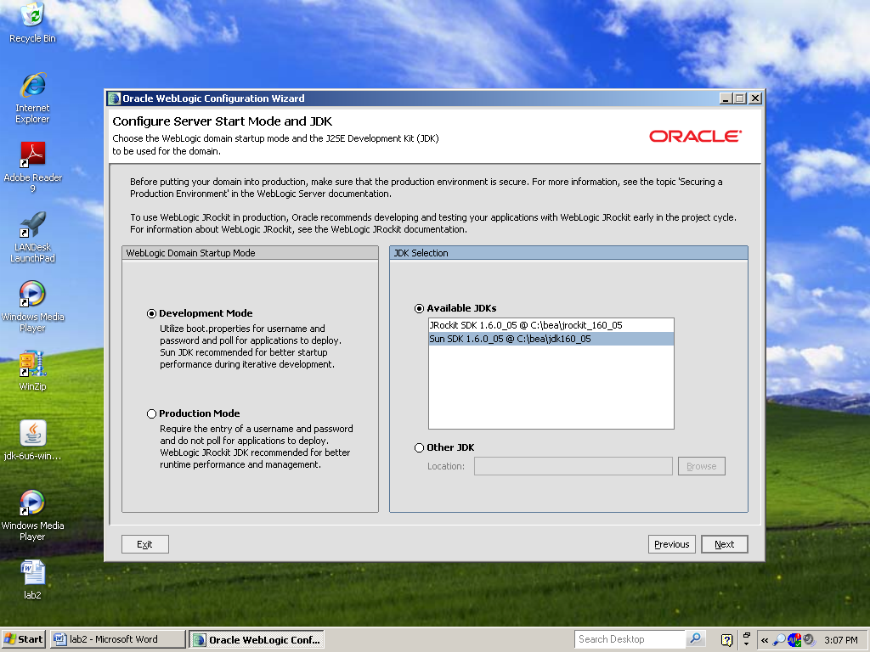

- Select the Custom option to create a domain with non-default template settings that meet the needs of your domain
- Optionally, define parameters for Java Database Connectivity (JDBC). Do not modify anything.
- Define parameters for the Administration Server, a designated server from which the domain is managed.
  - Name: AdminServer
  - Listen address: All Local Addresses
  - Listen port: 7001
  - SSL listen port: N/A
  - SSL enabled : Unchecked

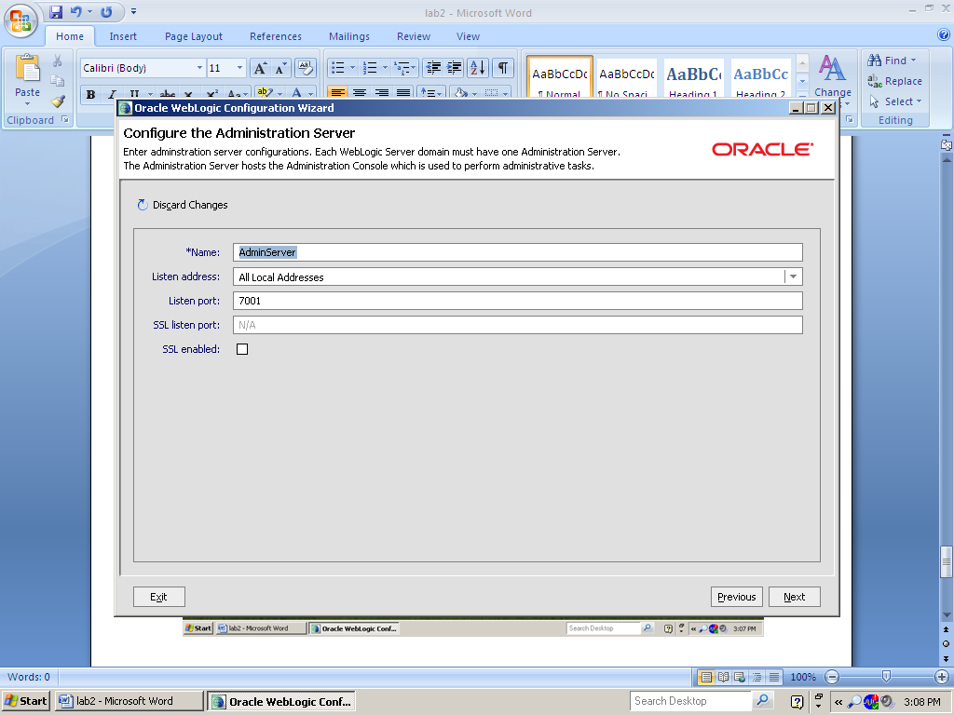

- Once the domain is created,
  - View directory structure at middleware\user_projects\domains\final_domain
  - View domain configuration file config.xml
- Start Admin server
  - Go to the bin directory of domain i.e. C:\Oracle\Middleware\user_projects\domains\final_domain\bin
  - Double click on the startWebLogic.cmd command

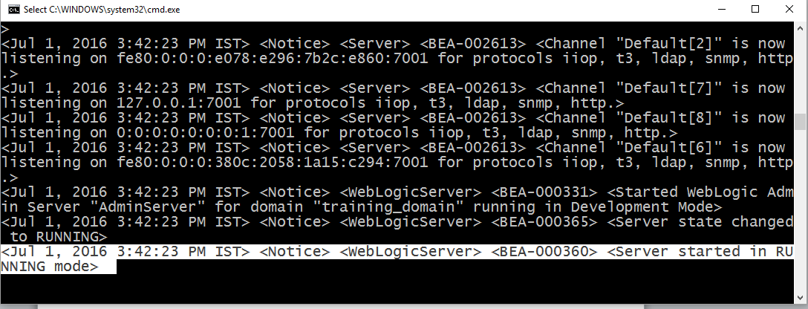

- Open Admin Console by typing following URL in web browser.
http://localhost:7001/console

- Enter user name and password as weblogic (or whatever you have selected in step 4)
- Expand the Environment link under wl_domain (on left hand side of the console), and click on Servers link.

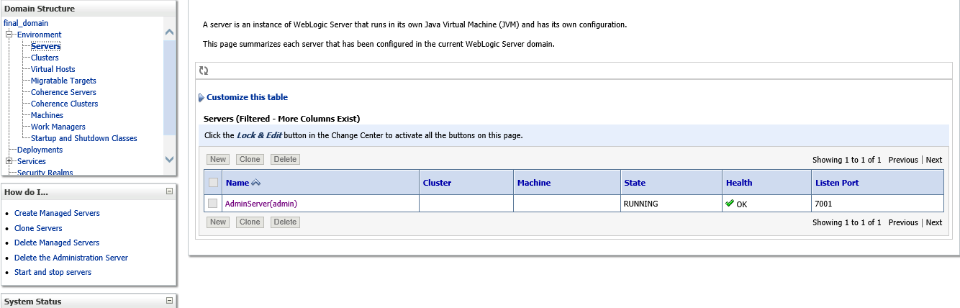

Lab3: Basic Deployment

Objective: Deploying an Application on WebLogic server
Steps
- Review the directory structure of the application
- Start Admin Server (if not already started)
- Open Admin Console by typing following URL in web browser.
http://localhost:7001/console
- Click on Deployments link under wl_domain (on left hand side of the console)
- It will display all the applications and libraries deployed in the domain.
- Click on Install button
- Select the path where application directory (or .war file) is stored
- Select MyWebApp.war for the deployment and click Next

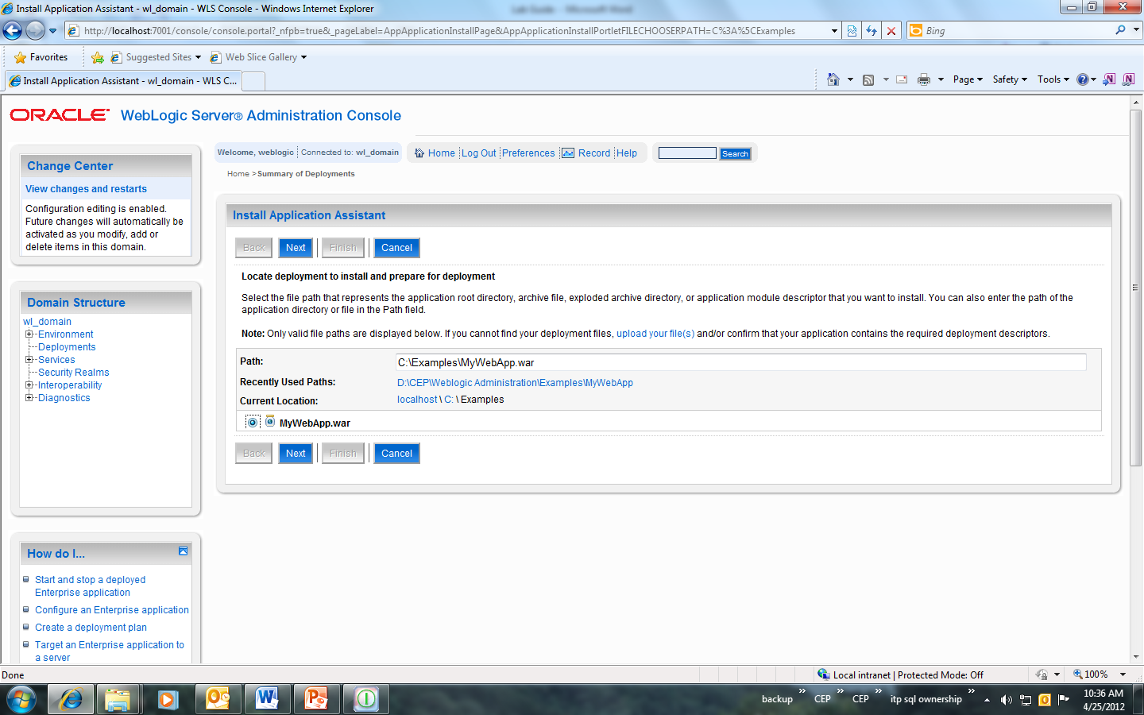

- Install this deployment as an application
- Select Admin Server as a deployment target
- Keep the name as it is (i.e. MyWebApp)
- Do not modify anything for Security and Source accessibility. Click on Next
- Review your choices and click Finish button
- It will take you to the settings page. Review the settings.
- Go back to the deployments. Your application will be listed there.
- Make sure that the state of the application is “Active”. If not, start the application by clicking on Servicing all requests link under Start link.
- Open web browser and type following URL to open the application
- Likewise you can deploy your applications and check them out.

Lab4: Configuring Data source

Objective: Setting JDBC data source and configuring connection pool

Steps
- Start Admin Server (if not started already)
- Open Admin Console by typing following URL in web browser.
http://localhost:7001/console
- Expand the Services link under final_domain
- Click on Data Sources link under Services link
- Click on New Data Source
- Select Generic Data Source
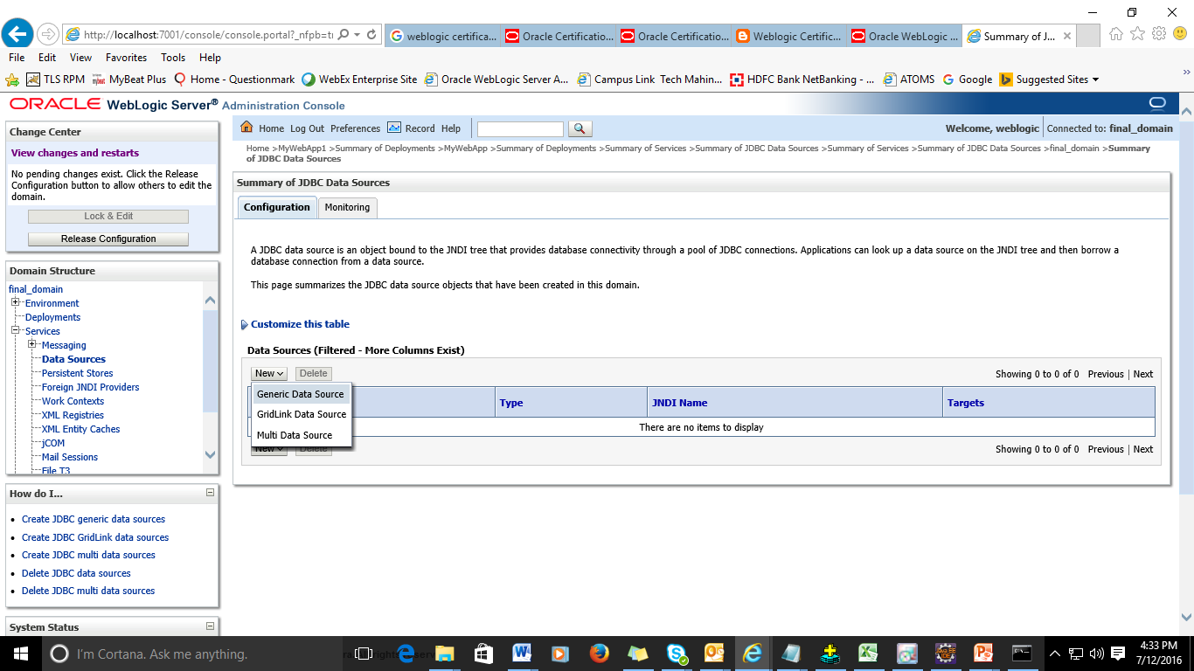

- Specify following properties
  - Name: DS1
  - JNDI Name: MyDS
  - lDatabase Type: Oracle
  - Database Driver: Oracle’s Driver (Thin) for Service connections; Versions: 9.0.1 and later.
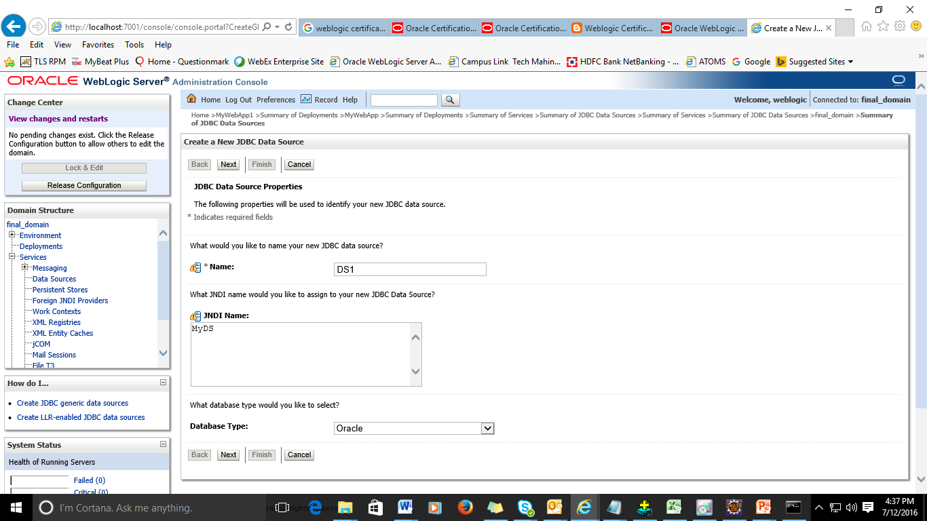

- Click on Next button
- Select Emulate Two-Phase Commit and then uncheck Supports Global Transaction box and click Next.
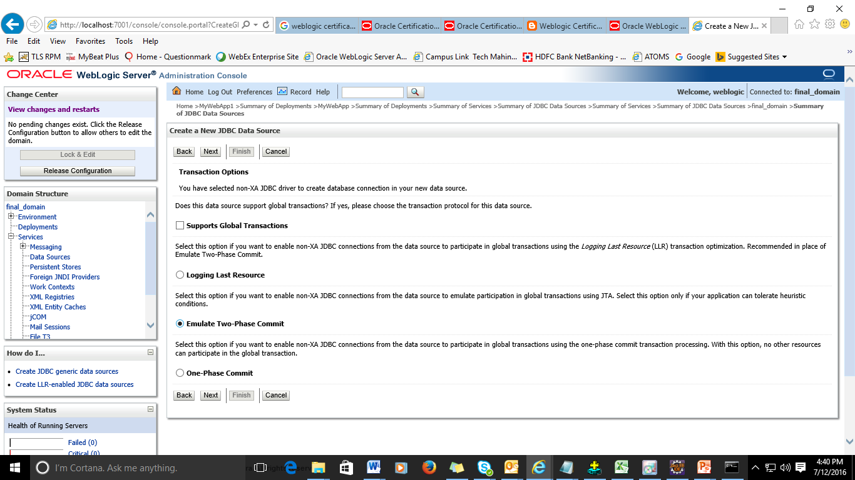
- Enter the below database related details :-

Database Name:- XE
Host Name:- localhost
Port:- 1521
Database User Name:- hr
Password:- hr

Confirm Password:- hr
Click Next.
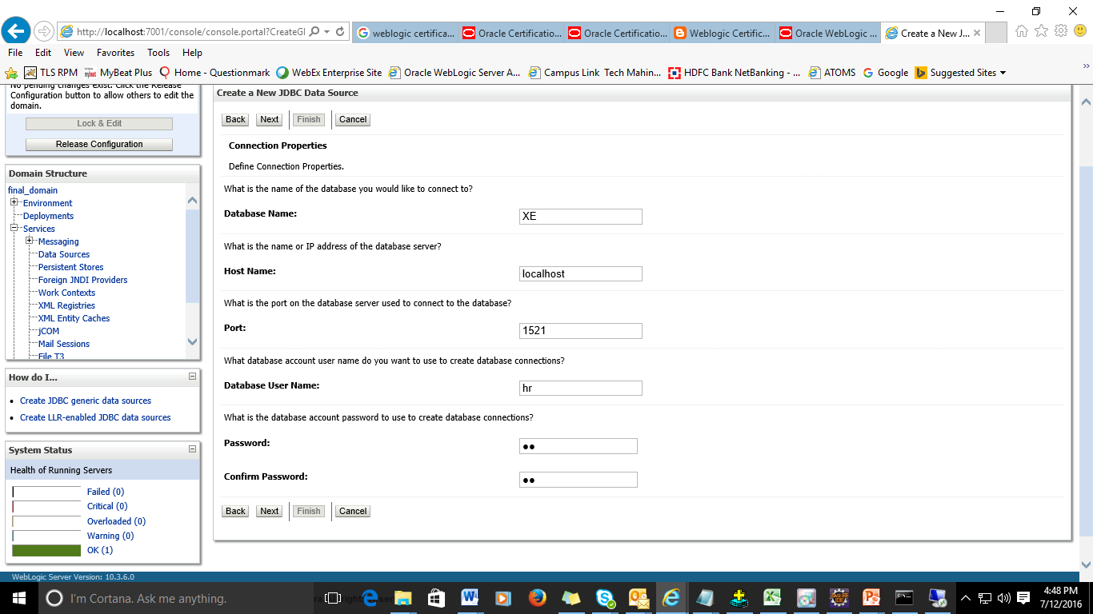

- Click next.
- Target the data source on Admin Server
- Click on DS1 => Monitoring.
- Select the radio button to test the connection by clicking on Test Data Source button.
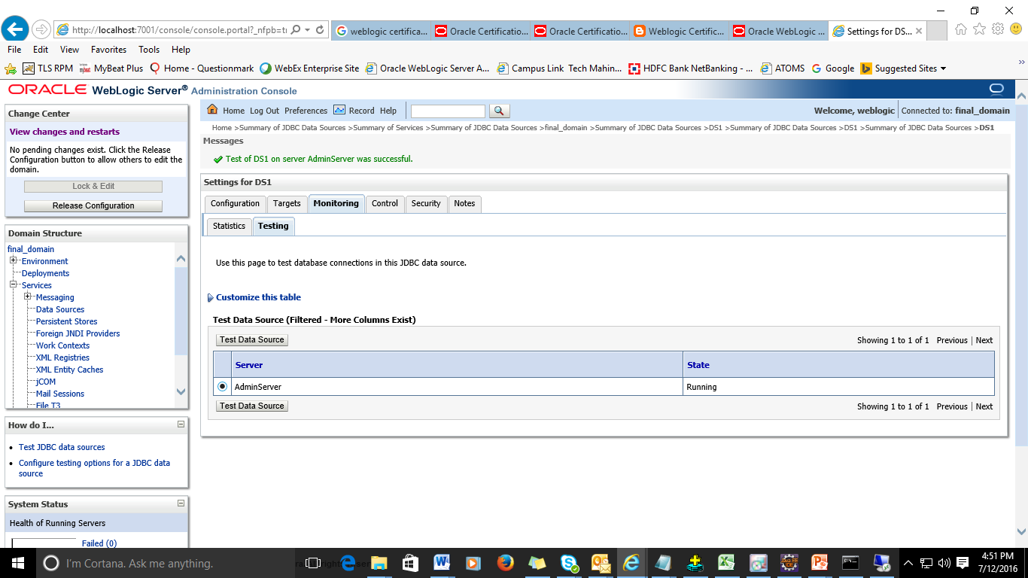

- Now Click on Servers => Admin Server => Click on view JNDI Tree.
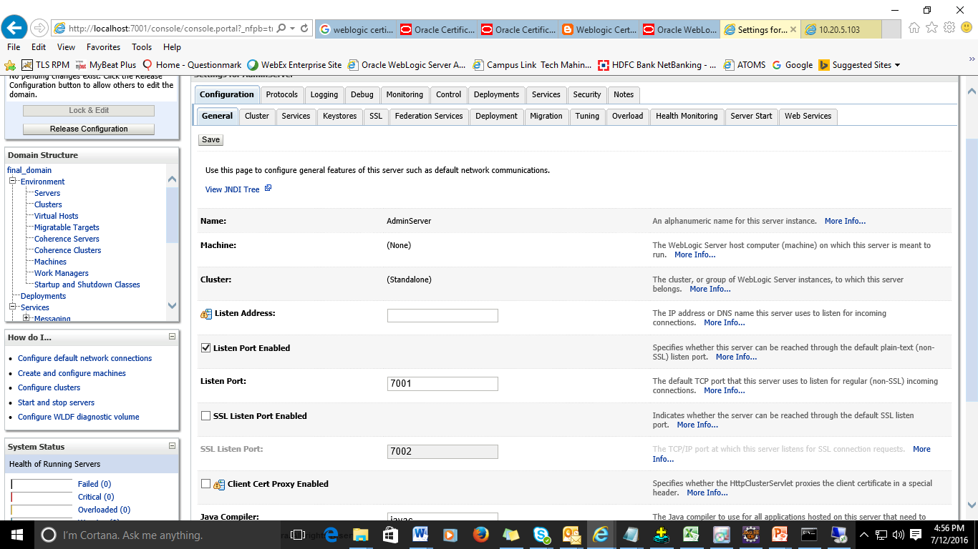

- Explore the JNDI tree to see the entry of data source.
- To configure connection pool, Expand the Services link under final_domain and click on Data Source link under JDBC link
- Click on DS1
- Go to the Connection Pool tab under Configuration tab
- You can modify the values of connection pool as per the requirement.
- Save the changes

References
- https://docs.oracle.com/cd/E13222_01/wls/docs90/

VERSION HISTORY

Version | Date | Author(s)/ Function | Approved by | Nature of Changes
0.01 | 12th July,16 | Aparna Vedpathak | Shweta Gandhi | -

